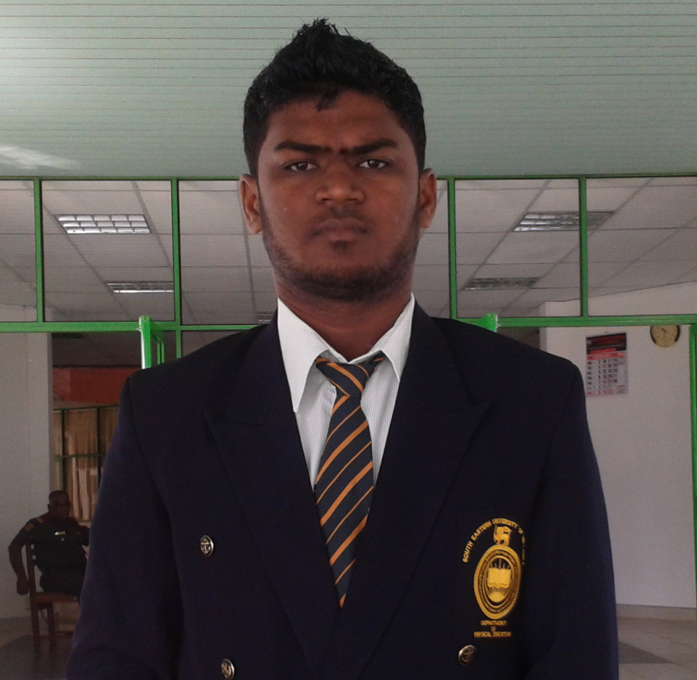
CURRICULAM VITAE

N. Sukri
Munthazah, Doha.
Mobile: 97477851790.
Email: sukrinajeeb@gmail.com
Position: Accountant

OBJECTIVE

To be associated with a progressive organization that gives me a opportunity to seek a challenging career to be part of a team that dynamically works towards steady growth.

EXPERIENCE

Period: 27th of April 2015 onwards
Organization: Wataniya Restaurants QSC
Designation: Assistant Accountant

Main duties:
- Preparation of monthly progress report.
- Preparation of pay sheet.
- Preparation of bank account reconciliation
- Monitoring stocks and company properties
- Daily sales report
- Daily bank reconciliation
- Monthly P&L
- Leave calculation
- Provisions for EOS, Air ticket and leave payment
- Receivable accounts

PERSONAL PROFILE

I am a management degree holder and. I am hard working, well organized with a wide range of useful skill. I work well in teams and my education experience includes working within diverse team.

PROFESSIONAL QUALIFICATION

- Successfully Completed CAB 1 (ICASL)
- Successfully completed diploma in computerized accounting
- Following ACCA (Reg no-3162558)

EDUCATIONAL QUALIFICATIONS

- Higher education

BBA(Hons)(Bachelor of Business administration) at South Eastern University of Sri Lanka (Special in Accounting) with second lower division

- G.C.E (O/L) 2005
- G.C.E (A/L) 2008

EXTRACURRICULAR ACTIVATES

- Participated in many career development work
- Cultural Festival and Education Exhibition

- I was a faculty student’s union member of south eastern university of Sri Lanka - (faculty of management & commerce-2008/2009)
- I was the editor of university student’s union of south eastern university of Sri Lanka -2008/2009
- I have completed diploma in English at British college of applied studies
- I have completed “leadership for entrepreneurial and administrative development” conducted by ministry of higher education

SKILLS

- Familiar with various Microsoft word, power point, excel, and internet & Email.
- Hard worker, committed to meeting deadlines and timely for shift work.
- Effective customer service and communication skills.
- Good in multi language (Tamil, Sinhala and English)
- Capable of working in a highly computerized environment.

PERSONAL DETAILS

- Full name : Najeeb Sukri
- Name with Initial : N.Sukri
- Address : munthazzah,doha
- Date of Birth : 29th December 1989
- Civil Status : Male
- Nationality : Sri Lankan
- Passport no : N5851122
- Mobile : 0097477851790
- Email : sukrinajeeb@gamil.com
- School Attended : T/mu/mutur central college
- Visa status : Transterable Visa with NOC

I do hereby certify that the particulars furnished by me in the application, are true and accurate to the best of my knowledge and if selected I shall perform my duties efficiently, loyally and your entire satisfaction.

Thank you
Yours respectfully

N.Sukri Date

